A
Mini Project Report
on
Pre Placement Management System
Submitted in fulfillment of the requirements for the degree
Second Year Engineering – Computer Science Engineering(Data Science)
by
Durvesh Wagle 23107019
Ahan Upadhye 23107027
Aayush Thakur 23107015
Shrikant Thakur 23107045

Under the guidance of
Mrs. Aavani Nair

DEPARTMENT OF COMPUTER SCIENCE ENGINEERING(DATA SCIENCE)
A.P. SHAH INSTITUTE OF TECHNOLOGY
G.B. Road, Kasarvadavali, Thane (W)-400615
UNIVERSITY OF MUMBAI

Academic year: 2024-2025

CERTIFICATE

This to certify that the Mini Project report on MoShop has been submitted by
Mr. Siddharth Kumar (23107044), Mr. Sarvesh Deve (23107021) and Mr. Yash Patil (23107007) and Mr. Arjun Talekar (23107005) who are bona fide students of
A. P. Shah Institute of Technology, Thane, as a partial fulfillment of the requirement for the degree in Computer Science Engineering (Data Science) during the academic year 2024-2025 in a satisfactory manner as per the curriculum laid down by the University of Mumbai.

Ms. Poonam Pangarkar
Guide

Ms. Anagha Aher Dr. Uttam D. Kolekar
HOD, CSE(Data Science) Principal

External Examiner: Internal Examiner:

Place: A. P. Shah Institute of Technology, Thane
Date:

ACKNOWLEDGEMENT
This project would not have come to fruition without the invaluable help of our guide Ms. Poonam Pangarkar. Expressing gratitude towards our HoD, Ms. Anagha Aher, and the Department of Computer Science Engineering (Data Science) for providing us with the opportunity as well as the support required to pursue this project. We would also like to thank our project coordinators Prof. Rajashri Chaudhari and
Prof. Vaibhav Yavalkar who gave us their valuable suggestions and ideas when we were in need of them. We would also like to thank our peers for their helpful suggestions.

TABLE OF CONTENTS

- Introduction…………………………………………………………………....1
  - Purpose…………………………………………………………………...1
  - Problem Statement……………………………………………………….2
  - Objectives………………………………………………………………...2
  - Scope……………………………………………………………………..3
- Proposed System………………………………………………………….…...4
  - Features and Functionality…………………………………………...…..4
- Project Outcomes……………………………………………………………...6
- Software Requirements………………………………………………………..7
- Project Design …………………………………………………………………8
- Project Scheduling……………………………………………………………..10
- Results …………………………………………………………………………11
- Conclusion……………………………………………………………………..17
References

Chapter 1
Introduction
The Pre-Placement Management System (PPMS) is a comprehensive and user-friendly application designed to streamline the campus recruitment process for both students and educational institutions. Our platform aims to bridge the gap between students and recruiters, facilitating efficient coordination and communication during pre-placement activities. PPMS Creates a seamless connection between students and recruiters. Simplify the recruitment process for students, faculty, and placement officers. Provide easy access to placement-related information.

1.1. Purpose
We believe that every student deserves a fair and organized opportunity to showcase their skills to potential employers. Through PPMS, we aim to foster an environment where courses are offered to make your resume more appealing to potential employers, helping students launch their careers successfully.
Organization: The system provides a centralized platform for managing student data, job postings, and placement activities, keeping everything in one place.

Prioritization: Prioritization: The system enables prioritization of tasks and activities based on importance, and deadlines, ensuring that critical tasks are addressed first.

Time Management: The system aids in allocating time efficiently by breaking down larger tasks into smaller, more manageable steps, and estimating the time needed for each task.

Productivity: The system encourages productivity by providing a clear outline of tasks and activities, helping to avoid procrastination and stay focused.

Accountability: The system serves as a reminder of commitments and deadlines, making it easier to stay on track and meet targets.

Stress Reduction:. The system reduces the feeling of being overwhelmed by providing a structured approach to managing placement activities, giving users a sense of control over their responsibilities.

Progress Tracking: The system provides a visual representation of progress, allowing users to track and measure the success of placement activities.

Goal Achievement: The system helps in setting and achieving both short-term and long-term placement goals by breaking them down into actionable steps, ensuring that users are working towards a common objective.
In summary, PPMS is a practical tool that helps in offering courses that will improve your portfolio and will also help you to stay organized, focused, and productive, ultimately leading to more effective task management and goal achievement.

1.2. Objectives
The objectives of a to-do list are as follows:
  - Task Organization: To systematically capture and categorize student data, job postings, and placement activities, ensuring that all responsibilities are clearly outlined and nothing is overlooked.

2. Prioritization: To enable users to prioritize placement-related tasks and activities based on their urgency, importance, and deadlines, helping them focus on what needs to be done first.
3. Time Management: To assist users in managing their time effectively by allocating time slots for specific placement-related tasks and estimating the time required to complete each task.
4. Productivity Enhancement: To boost productivity by providing a clear roadmap of placement-related tasks, reducing procrastination, and encouraging users to stay on track.
5. Progress Tracking: To allow users to monitor their progress by tracking placement statistics, giving them a sense of accomplishment and motivation to continue.
6. Stress Reduction: To reduce stress by organizing placement-related tasks in a manageable way, helping users feel more in control of their workload.
7. Goal Achievement: To facilitate the setting and achieving of both short-term and long-term placement goals by breaking them down into actionable steps that can be tracked and completed.
8. Accountability: To keep users accountable for their placement-related tasks by providing a visual reminder of their commitments, ensuring that deadlines and responsibilities are met.
9. Flexibility: To provide a customizable and adaptable system that can accommodate the unique needs and workflows of different colleges and universities, allowing users to tailor the system to their specific requirements and preferences.
These objectives help ensure that a PPMS serves its primary function of improving time management, and overall productivity.

  - Scope
The scope of PPMS encompasses several key areas. Here's a breakdown of the scope:

1. Time Management
Reminders and Alerts: Provides notifications or reminders to alert users of upcoming deadlines or overdue tasks.
Time Estimation: Enables users to estimate the time required for each task, helping in planning and scheduling.
2.Progress Tracking
Status Indicators: Includes options to mark tasks as "completed," "in progress," or "pending," helping users track their progress.
Task History: Allows users to view a history of completed tasks for reference and motivation.
3. User Interaction
Subtasks and Checklists: Provides the ability to break down larger tasks into smaller, manageable subtasks or create checklists within a task.
4. *Collaboration*
Shared To-Do Lists: Enables multiple users to share and collaborate on a to-do list, which is useful for teams or families.
Task Assignment: Allows tasks to be assigned to specific individuals, with clear ownership and responsibility.
5. *Integration and Accessibility*
Integration with Other Tools: Integrates with calendars, email, and project management tools for a seamless workflow.
Offline Access: Offers offline functionality, so users can manage their tasks without an internet connection.
6. *Security and Privacy*
User Authentication: Includes login mechanisms to protect access to personal or shared to-do lists.
7. Analytics and Reporting
Progress Reports: Provides users with insights into their productivity, such as the number of tasks completed over time.
8. Limitations
Complex Projects: While effective for day-to-day task management, a to-do list may not fully support complex project management needs that require more advanced tools (e.g., Gantt charts, resource allocation).

Over-Reliance: Users might become overly dependent on the to-do list, potentially leading to stress if tasks are not completed as planned.
The scope of a to-do list is broad, covering various aspects of task management, time management, collaboration, and user customization. It is designed to be a versatile tool that can adapt to both personal and professional use, helping users stay organized, productive, and on top of their responsibilities. However, it's important to recognize its limitations in handling more complex project management scenarios.

Chapter 2
Proposed System

The Pre-Placement Management System (PPMS) is designed to streamline and automate the various processes involved in preparing students for placement opportunities. This system enables seamless coordination between students and the placement cell by providing a centralized platform for managing pre-placement activities such as training sessions, aptitude tests, and access to relevant course links. With features like automated notifications and real-time updates, the PPMS ensures efficient communication and reduces manual effort. It allows students to stay informed about important pre-placement events, courses, and deadlines, improving their overall readiness for future job opportunities.

2.1. Features and Functionality
- Student Profile Management: A personal info page shows all the information provided by the user during the registration process, including academic records, contact details, and other essential information.
- Courses Page Based on CGPA: The courses page offers personalized course recommendations based on the student’s CGPA. High-performing students may have access to advanced courses, while others are guided toward skill-building and foundational courses relevant to their CGPA.
- Job Search Page with Recommendations: The job search page provides a list of jobs that match the student's qualifications and preferences. The system recommends jobs based on factors like the student's CGPA, skill set, and past activities, helping them find relevant opportunities more efficiently.
- Pre-Placement Activity Scheduling: The system manages the scheduling of pre-placement activities, including training sessions, workshops, and mock interviews, and presents this information via an easy-to-use event calendar.
- Automated Notifications and Reminders: Students receive automated notifications about upcoming events, deadlines, course recommendations, and job opportunities, keeping them informed and engaged.
- Settings Page: A dedicated settings page allows users to manage their preferences, including notification settings, privacy options, and other personalized preferences to customize their experience.
- Real-Time Updates: Real-time updates ensure that students are always aware of changes to course offerings, new job listings, and updated schedules for pre-placement activities.
- Document and Certificate Management: Students can upload and manage important documents such as certificates from completed courses, training programs, and workshops.

Key Features:
- Courses Page with CGPA-Based Recommendations: Personalized courses tailored to students’ academic performance, helping them focus on relevant learning paths.
- Job Search and Recommendations: A curated list of job opportunities, automatically recommended based on the student’s qualifications, ensuring better job matching.
- Personal Info Page: Centralized access to all personal information provided during registration, giving users full visibility of their data.
- Automated Notifications: Timely alerts for important pre-placement events, course opportunities, and job listings.
- Settings Page: Allows students to customize their experience by adjusting notification settings and managing their personal preferences.
- Event Calendar: An organized calendar that tracks all scheduled pre-placement activities and job deadlines.

Chapter 3
Project Outcomes
The Pre-Placement Management System (PPMS) aims to outcome the preparation process for students by providing a comprehensive platform that streamlines access to resources, job opportunities, and personal information management. By integrating various functionalities such as CGPA-based course recommendations, job search features, and automated notifications, the system ensures that students are well-equipped to tackle the challenges of placement preparation. The following outcomes highlight the expected benefits and improvements that the PPMS will deliver for students and the placement cell.

- Improved Student Preparation: Students will be better prepared for placement opportunities through access to personalized courses based on their CGPA, targeted job recommendations, and participation in pre-placement activities like training sessions and workshops.
- Efficient Job Search and Recommendations: Students will benefit from a more streamlined job search process, receiving job recommendations tailored to their academic qualifications, skills, and preferences, reducing the time spent searching for relevant opportunities.
- Centralized Management of Personal Information: All personal, academic, and registration data will be centralized in one easily accessible location, enabling students and the placement cell to manage and update information seamlessly.
- Enhanced Student Engagement: Automated notifications and reminders will keep students engaged and informed about important events, courses, and job listings, helping them stay on track with pre-placement activities and deadlines.

Chapter 4
Software Requirements
The software requirements section of the Pre Placement Management System project report outlines the essential technical specifications needed for the e-commerce platform. It includes functional requirements, detailing specific features like user authentication and product management, as well as non-functional requirements that address performance, security, and usability.

Front-end Development:
- Java JDK (Version 22.0.2)- Java will be used to build a robust and user-friendly interface, leveraging its object-oriented features to create scalable and maintainable code. Java's versatility allows for the development of interactive web applications that enhance the overall user experience.

Back-end Development:
- MySQL (Version 8.0.1)- MySQL will serve as the database management system, handling user profiles, product data, and transaction records. Its relational database structure allows for efficient data retrieval and storage, ensuring the integrity and security of the information.

Additional Technologies:
- Java JDK (Java Development Kit)- The Java JDK is a comprehensive suite of tools for developing Java applications. It includes the Java Runtime Environment (JRE), development tools, and libraries necessary for building, testing, and deploying Java applications, making it essential for the MoShop project.
- NetBeans Apache Software (Version22.0)- NetBeans is an integrated development environment (IDE) that supports Java and other languages. It provides a user-friendly interface for coding, debugging, and testing applications, making it easier for developers to manage the MoShop project efficiently
Chapter 5
Project Design
The design of our e-commerce store project is structured to facilitate a seamless user experience while providing comprehensive administrative controls. At the core of the system is a block diagram that outlines the main functionalities for both users and administrators.
For users, the process begins with a user login feature, allowing new customers to register and returning customers to log in securely. Once logged in, users can easily search for products using a search functionality, view detailed product information, and add desired items to their shopping cart. The user journey culminates in the generation of a receipt upon checkout, confirming the order and providing essential details for future reference.
On the administrative side, the project features a robust dashboard designed for efficient management. Administrators have the ability to manage user accounts, oversee product listings, organize product categories, and handle advertisements to enhance store visibility. Additionally, the dashboard includes receipt management capabilities, enabling admins to track and manage customer orders effectively. This dual functionality ensures that both user and admin needs are met, promoting a streamlined and efficient e-commerce environment.
Chapter 6
Project Scheduling

Project scheduling is a crucial aspect of effective project management, providing a roadmap for the timely completion of tasks and milestones within a defined timeframe. To visualize this schedule, a Gantt chart is employed, providing a graphical representation of task durations, start and finish dates, and interactivity. Additionally, Gantt charts help illustrate the project's work breakdown structure and the relationships between activities, ensuring effective project management and progress tracking. The detailed explanation of the Gantt chart is explained below after Figure 6.
Figure 6.1 : Gantt Chart of Pre Placement Management System
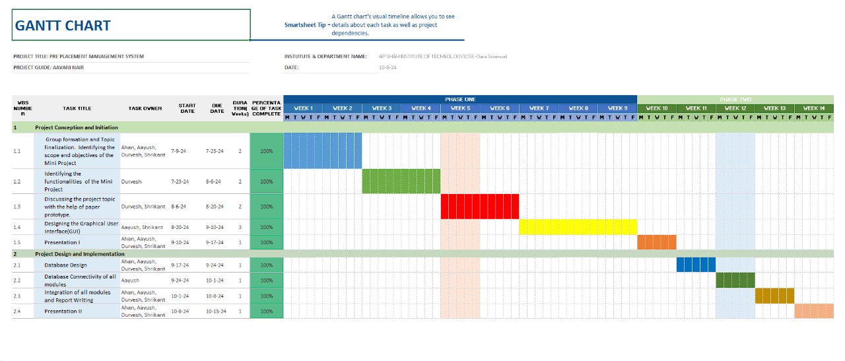

Following is the detail of the Gantt chart – In the third week of July, Durvesh Wagle, Aayush Thakur, Ahan Upadhye, Shrikant Thakur formed a group for their mini- project. They discussed and finalized the project's topic, scope, and objectives during this meeting. In the following weeks, Durvesh Wagle, Aayush Thakur, Ahan Upadhye, Shrikant Thakur used a paper prototype to explore and refine project ideas, completing this phase by the 2nd week of August.
In late September, they executed the design and integration of the graphical user interface (GUI). Afterward, on the 12th of September, the first project review took place, and the faculty suggested some changes to the GUI, which were subsequently approved.
Following this, Aayush Thakur and Shrikant Thakur collaborated in designing the GUI and connecting the database to the project, while Yash Patil and Siddharth Kumar focused on documentation and report writing. This database work was completed by the end of September. Finally, the team integrated all modules and completed the report writing, resulting in their final presentation on the 19th of October, which was approved by the faculty.

Chapter 7
Results
The results section showcases the successful implementation of our project through a series of detailed photographs. These images highlight key stages of development, including the design of the graphical user interface, database integration, and the overall functionality of the MoShop platform. By visually documenting our progress, we provide clear evidence of our efforts and the effectiveness of our solutions. The photos serve not only to illustrate our work but also to demonstrate the seamless user experience and the robust architecture of the e-commerce system we have created.
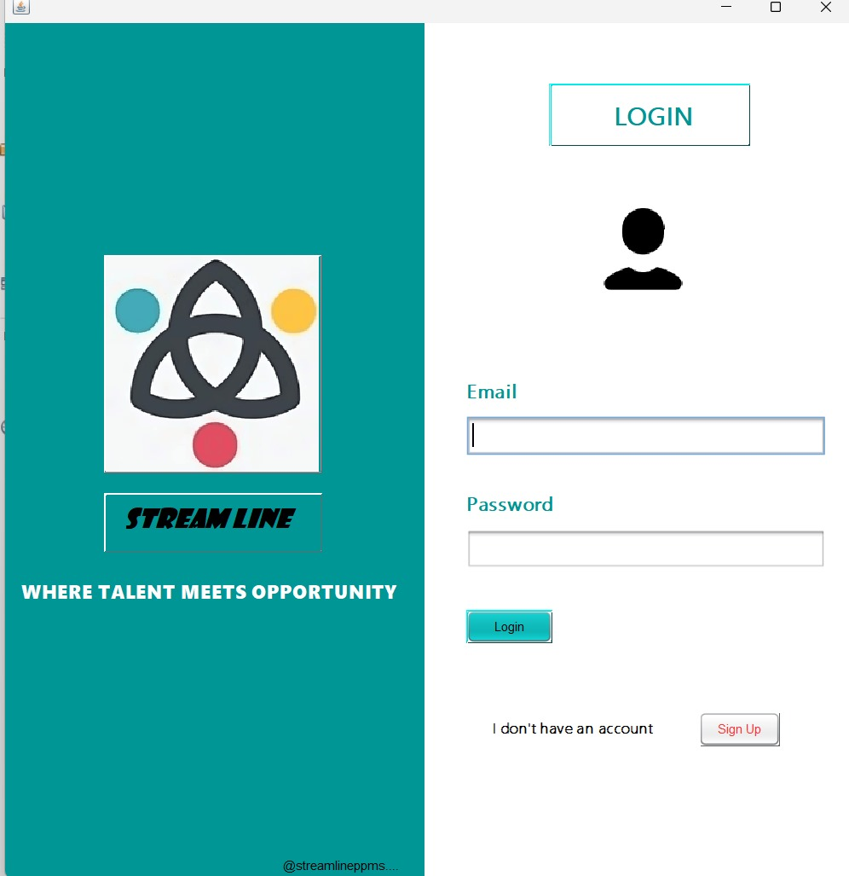
Figure 7.1 : Sign In Page
Figure 7.1 above shows the login page, which serves as the gateway for both users and administrators to access their respective accounts on the e-commerce platform. It features separate input fields for entering a username and password for each type of login. Users can register for new accounts, while administrators can log in to access management tools. The design prioritizes user-friendliness and security, ensuring a smooth authentication process while protecting sensitive data.
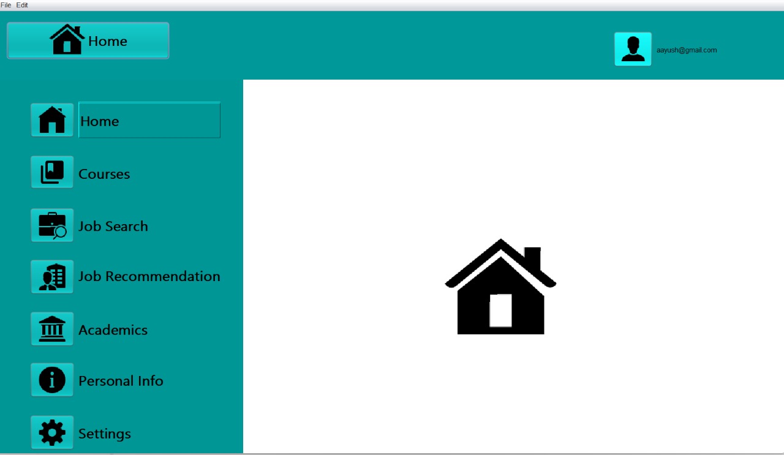

Figure 7.2: Sign In Page
Figure 7.2 above showcases the home page layout, highlighting the focus on the login button and the carefully curated ads that enhance visual appeal. This combination creates a cohesive environment that encourages user interaction and sets the stage for exploring placement system offerings.

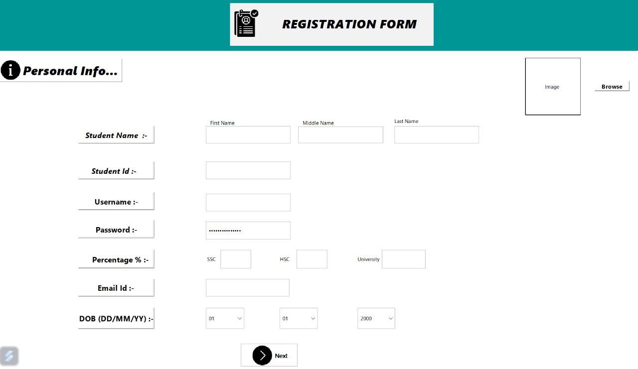
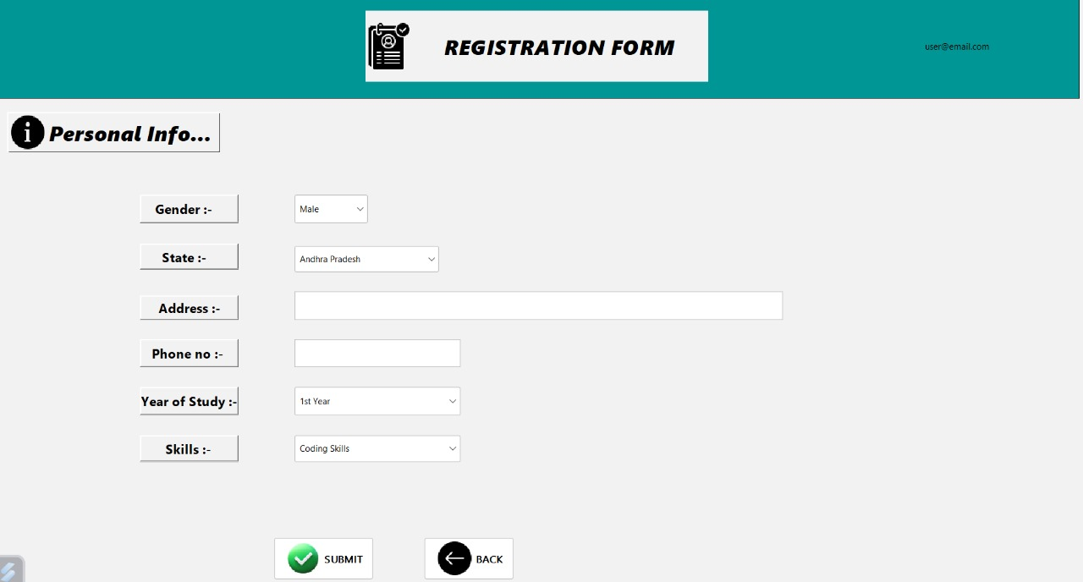

Figure 7.3: Registration Page
Figure 7.3 above shows the signup page, where new users can easily create accounts on the e-commerce platform. This page features fields for entering essential information, such as name, email, and password, along with options for additional details as needed. The straightforward design ensures that the registration process is quick and user-friendly. Once registered, users gain access to personalized features, enhancing their overall engagement with the platform.

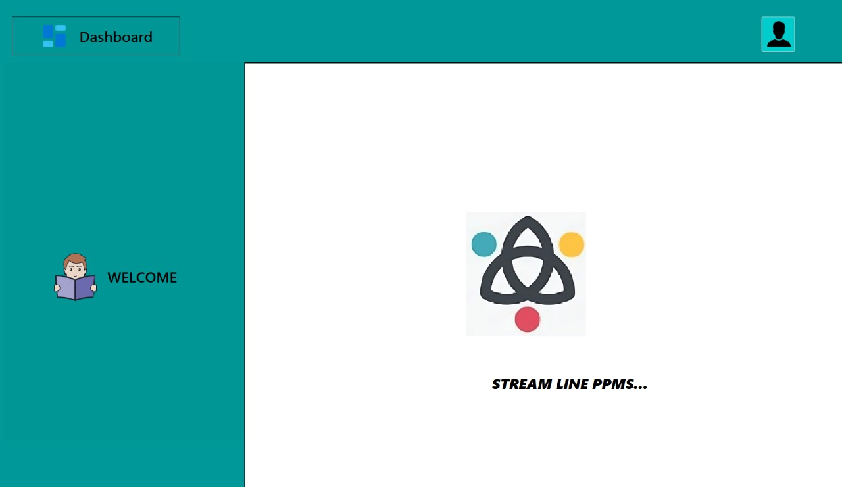

Figure 7.4: Admin Dashboard
Figure 7.4 above shows the admin dashboard, which serves as the central hub for managing categories, users, and user info. This intuitive interface allows administrators to efficiently organize categories, ensuring accurate product classification. User management features enable quick addition, deletion, and searching of users, enhancing control.
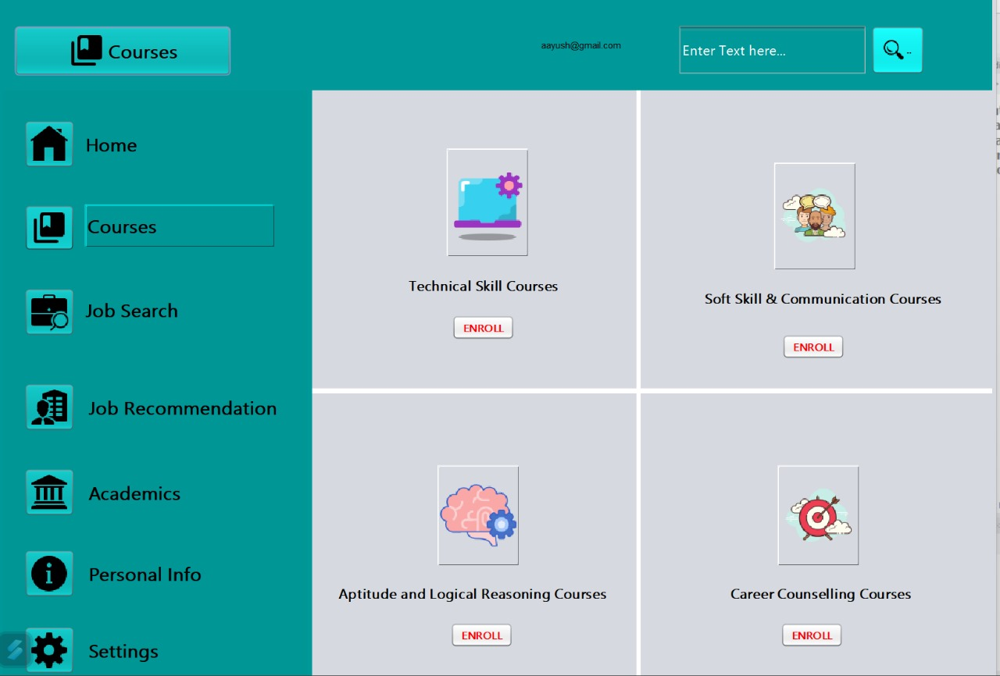
Figure 7.5: Courses Page
Figure 7.5 above shows all the types of courses offered to the student such as Technical Skill Courses, Soft Skill & Communication Courses, Aptitude and Logical Reasoning Courses and Career Counselling Courses. The Student can enroll in these given courses and will then be redirected to the following course.
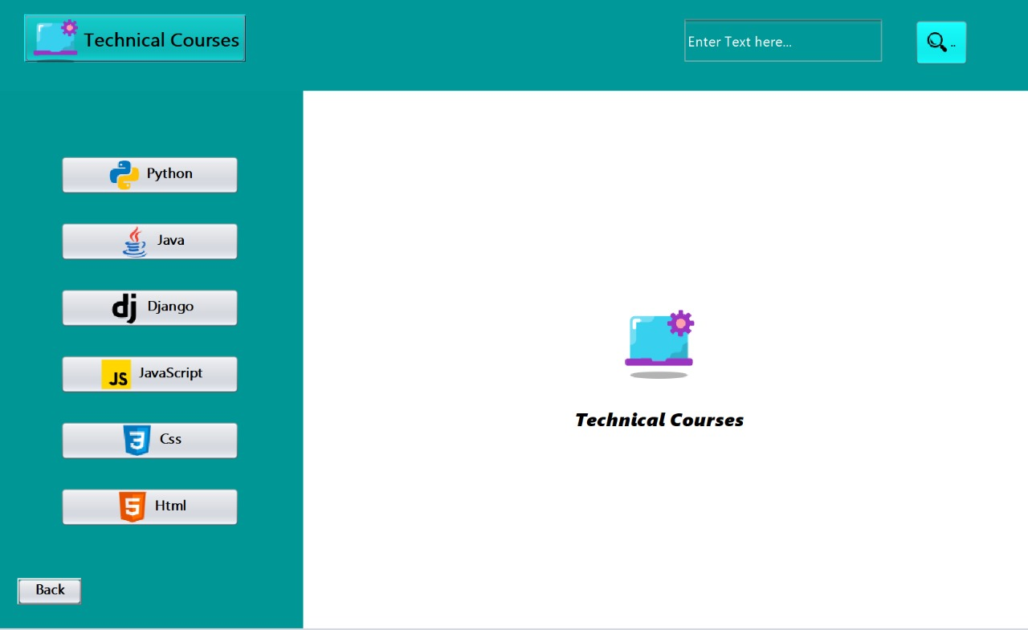
Figure 7.6: Technical Courses
Figure 7.6 above shows the Technical Skill Courses, where users can oversee the enlisted courses given based on the users/students CGPA . This page allows for the addition of new courses, updates to your academic portfolio. In this case , we have a course for Python, Java, Django, Java Script, Css, and Html. This will change according to the CGPA. For eg. If a user gets below 7 CGPA, some of the courses will not be available.

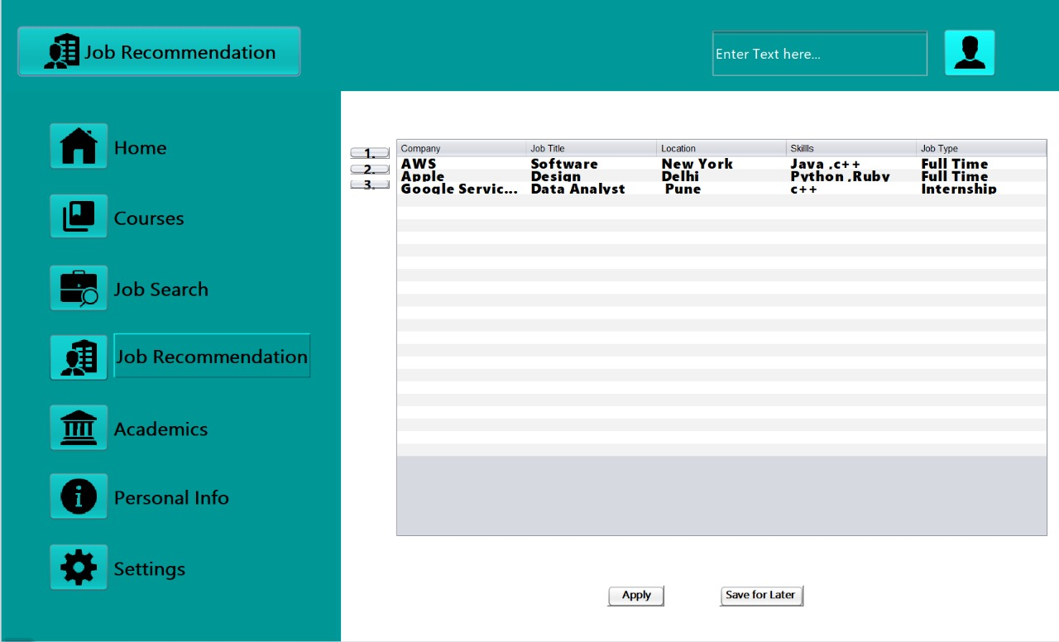
Figure 7.7: Job Recommendation Page
Figure 7.7 above shows the Job Recommendation page, where users can apply for Jobs. This functionality enables job listings with essential details such as title, company, location and job type. The user can click on any link and apply for the specific job the user wants to apply for. By integrating these functionalities, a job suggestion page not only simplifies the job search process.
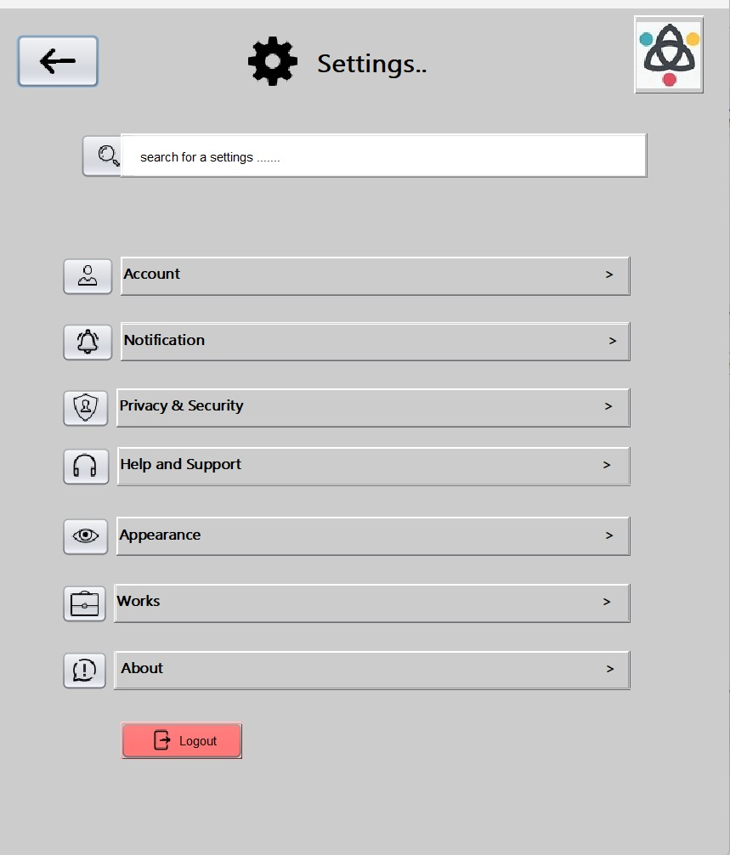

Figure 7.8: Settings Page
Figure 7.8 above shows the settings page which is an essential component of any application, allowing users to customize their experience and manage various preferences.
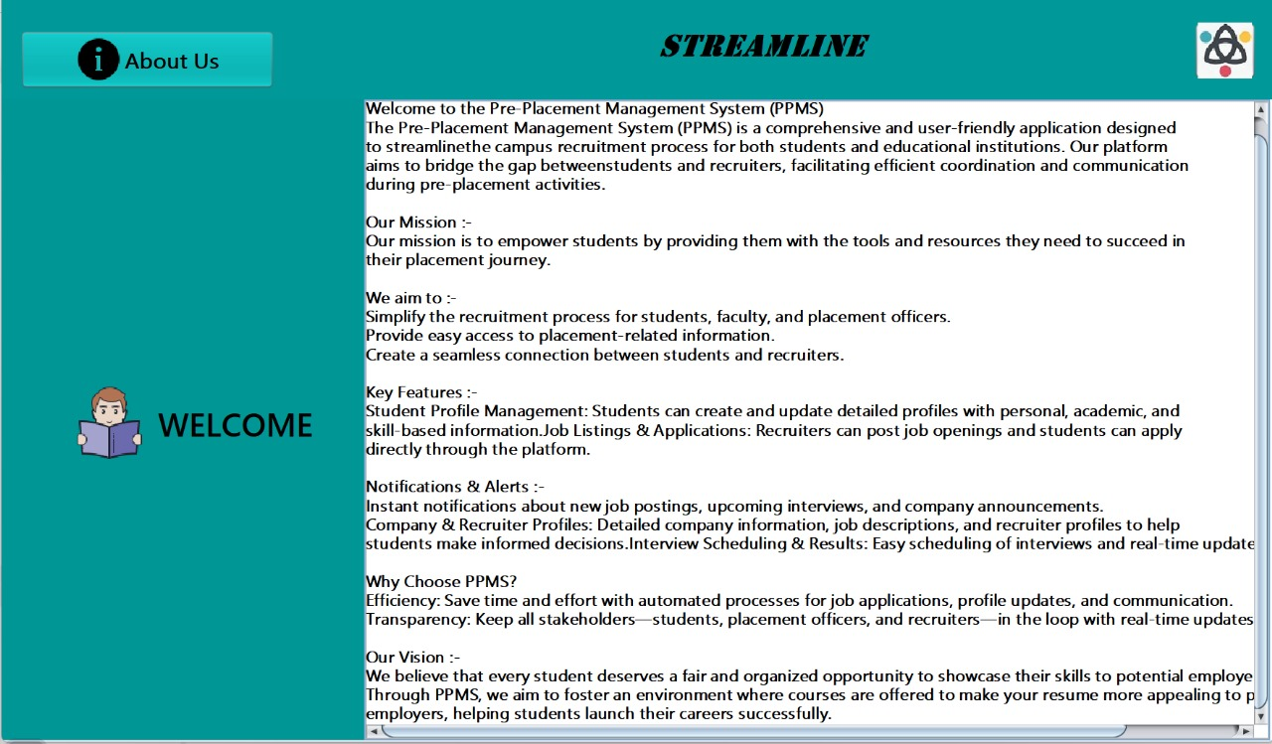
Figure 7.9: About Us Page
Figure 7.9 above shows the About Us page, which is a vital section of a website that provides insight into our system which is Pre Placement Management System. It serves not only to inform visitors about the system’s identity

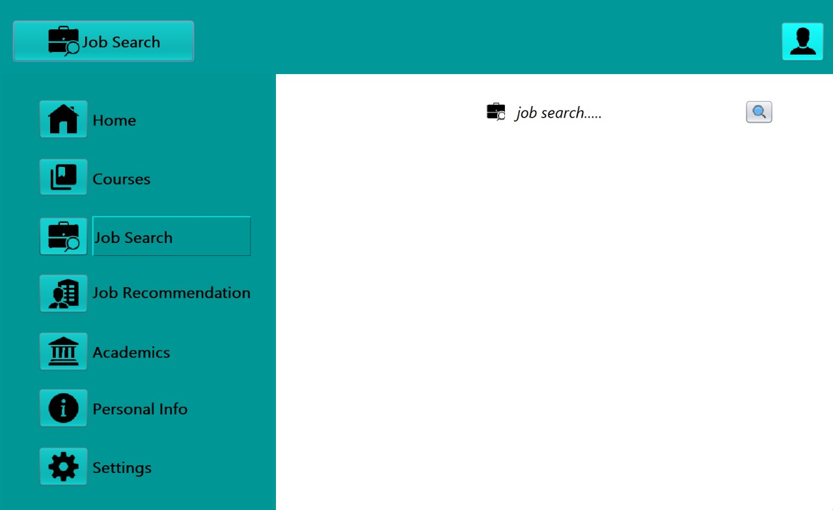

Figure 7.10: Job Search Page
Figure 7.10 above shows the user dashboard page, which features prominently displayed buttons for key actions: "Purchase," "Purchase Details," and "My Account." The "Purchase" button directs users to explore available products, while "Purchase Details" allows them to view their order history. The "My Account" button enables users to manage their profile and settings. The design is user-friendly and intuitive, ensuring seamless navigation and enhancing the overall shopping experience on the platform.

Chapter 8
Conclusion

In conclusion, the Pre-Placement Management System (PPMS) is a valuable tool that simplifies and enhances the pre-placement process for students. By offering features such as personalized course recommendations, an efficient job search with tailored recommendations, and easy access to personal information, the system empowers students to prepare more effectively for future opportunities.Ultimately, this system provides a streamlined, organized approach to pre-placement activities, improving the overall readiness of students for the job market.
References
[1] Abror Abduvaliyev, Al-Sakib Khan Pathan, Jianying Zhou, Rodrigo Roman and WaiChoong Wong,“On the vital Areas of Intrusion Detection Systems in Wireless Sensor networks”, IEEE Communications Surveys & Tutorials, Accepted For Publications, 2013-in press.
[2] H.H. Soliman, et al, “A comparative performance evaluation of intrusion detection techniques for hierarchical wireless sensor networks”, Egyptian Informatics Journal (2012) 13, 225238.
[3] Giannetsos Athanasios, “Intrusion Detection in Wireless Sensor Networks”, Master THESIS, Carnegie Mellon University, April 8, 2008.
[4] K.Fall and K.Varadhan,“The NS Manual”, http://www.isi.edu/nsnam/ns/doc/ns doc.pdf., 1 Feb 2014.
[5] Jae Chung and Mark Claypool,“NS by Example-Tutorial”, http://nile.wpi.edu/NS/overview.html , 1 Feb 2014.
[6] Network Simulator blog, http://Mohittahilani.blogspot.com , 1 Feb 2014.
[7] AWK Script for NS2, http://mohit.ueuo.com/AWK-Scripts.html , 1 Feb 2014.

